5.28: a) The stopping distance is
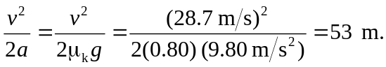
b) The stopping distance is inversely proportional to the coefficient of friction and proportional to the square of the speed, so to stop in the same distance the initial speed should not exceed
